**Practical 4 : write a shell script to generate marksheet of a student. Take 3 subjects,calculate and display total marks, percentage and Class Obtained by the students.**

echo "my name is harsh vadgama"

echo "my enrollment is 92410103123"

echo "my class is 4-EC5"

echo "enter your name : "

read name

echo "enter enrollment : "

read enrollment

echo "enter marks out of 100 :"

echo "enter for maths"

read maths

echo "enter for english"

read english

echo "enter for physics"

read physics

sum=$((maths+english+physics))

percent=$(((sum*100)/300))

echo "-------student marksheet--------- "

echo " "

echo "name : $name"

echo "enrollment : $enrollment"

echo "total : $sum"

echo "percentage : $percent"

if [ $percent -ge 75 ]; then

echo "distinction"

elif [ $percent -ge 60 ]; then

echo "first class"

elif [ $percent -ge 50 ]; then

echo "second class"

elif [ $percent -ge 35 ]; then

echo "pass"

else

echo "fail"

fi

echo " "

echo "---------------------------”

**Output:**

my name is harsh vadgama

my enrollment is 92410103123

my class is 4-EC5

enter your name :

harsh

enter enrollment :

123

enter marks out of 100 :

enter for maths

61

enter for english

61

enter for physics

61

-------student marksheet---------

name : harsh

enrollment : 123

total : 183

percentage : 61

first class

---------------------------

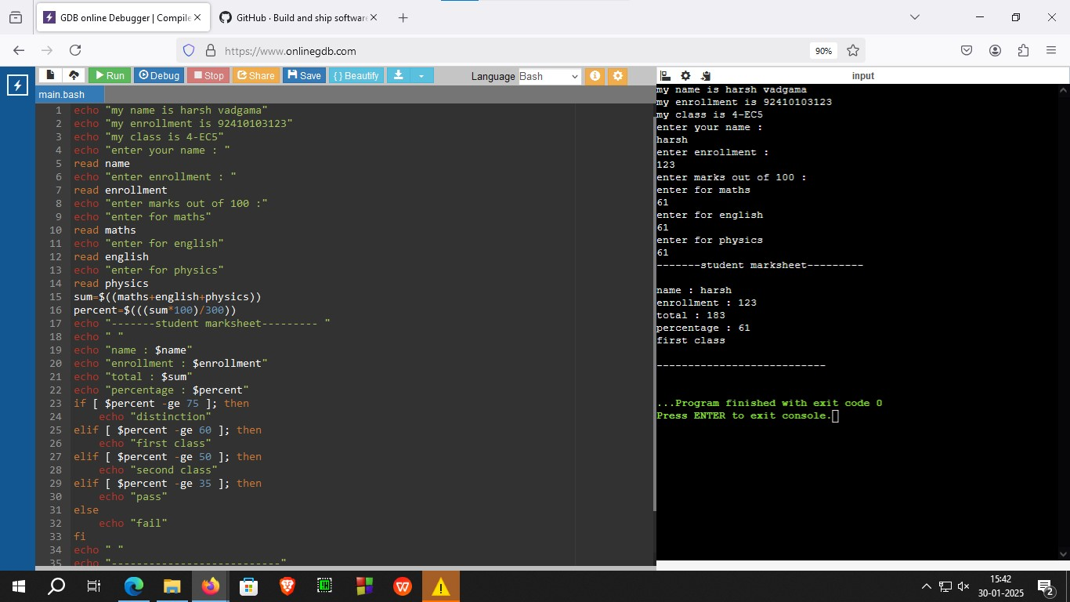

Figure 4.1 : program to print marksheet of student